**Lab Report. 01**

**Title: Lab Report**

*Course title: Computer Graphics Lab*

*Course code: CSE-304*

*3rd Year 1st Semester 2022*

**Date of Submission**: 28/05/2023



###### **Submitted to-**

###### Dr. Mohammad Shorif Uddin

###### Professor

*Department of Computer Science and Engineering*

*Jahangirnagar University*

*Savar, Dhaka-1342*

*And*

*Dr. Morium Akter*

###### Associate Professor

*Department of Computer Science and Engineering*

*Jahangirnagar University*

*Savar, Dhaka-1342*

|  |  |  |  |
| --- | --- | --- | --- |
| **Sl** | Class Roll | Exam Roll | Name |
| 01 | 367 |  | Fatima Binte Aziz |

Source code:

#include <iostream>

#include <graphics.h>

void LINE(int x1, int y1, int x2, int y2)

{

int dx = abs(x2 - x1);

int dy = abs(y2 - y1);

int sx = (x1 < x2) ? 1 : -1;

int sy = (y1 < y2) ? 1 : -1;

int err = dx - dy;

while (true)

{

putpixel(x1, y1, BLUE);

if (x1 == x2 && y1 == y2)

break;

int e2 = 2 * err;

if (e2 > -dy)

{

err -= dy;

x1 += sx;

}

if (e2 < dx)

{

err += dx;

y1 += sy;

}

}

}

int main()

{

int gd = DETECT, gm;

initgraph(&gd, &gm, "");

int x1 = 500, y1 = 500;

int x2 = 200, y2 = 200;

LINE(x1, y1, x2, y2);

getch();

closegraph();

return 0;

}

Output:



Source code:

#include <stdio.h>

#include <graphics.h>

int main()

{

int gd = DETECT, gm;

initgraph(&gd, &gm, "FIRST");

int x1 = 100, y1 = 100;

int x2 = 444, y2 = 333;

int dx = x2 - x1;

int dy = y2 - y1;

int steps = abs(dx) > abs(dy) ? abs(dx) : abs(dy);

float xInc = dx / (float)steps;

float yInc = dy / (float)steps;

float x = x1;

float y = y1;

for (int i = 0; i <= steps; i++)

{

putpixel(x, y, BLUE);

x += xInc;

y += yInc;

}

getch();

closegraph();

return 0;

}

Output:

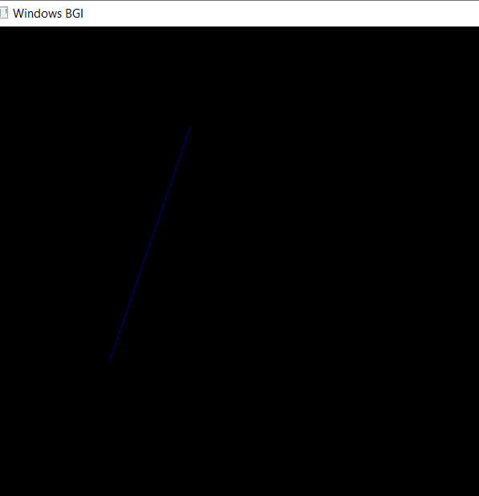

Source code:

#include<stdio.h>

#include<graphics.h>

#include<conio.h>

int main()

{

int gd = DETECT, gm;

initgraph(&gd,&gm, "second");

putpixel(222,222,WHITE);

getch();

closegraph();

}

Output:



Source code:

#include <iostream>

#include <graphics.h>

void Circle(int xc, int yc, int radius)

{

int y = radius;int x = 0;

int d = 3 - 2 * radius;

while (x <= y)

{

putpixel(xc + x, yc + y, BLUE);

putpixel(xc - x, yc + y, BLUE);

putpixel(xc + x, yc - y, BLUE);

putpixel(xc - x, yc - y, BLUE);

putpixel(xc + y, yc + x, BLUE);

putpixel(xc - y, yc + x, BLUE);

putpixel(xc + y, yc - x, BLUE);

putpixel(xc - y, yc - x, BLUE);

if (d < 0)

d += 4 * x + 6;

else

{

d += 4 * (x - y) + 10;

y--;

}

x++;

}

}

int main()

{

int gd = DETECT, gm;

initgraph(&gd, &gm, "third");

int xc = 300, yc = 300;

int radius = 150;

Circle(xc, yc, radius);

getch();

closegraph();

return 0;

}

Output:

